Ambient Systems  Building owners and operators often struggle to manage the indoor environment in real-time because of three underlying challenges.  Air Quality  Indoor air quality is essential for creating an optimal indoor environment, yet it is difficult to measure in real-time.  Technological Complexity  Building operations consist of complex legacy systems and machinery that controls cooling, ventilation, and other processes.  Competing Priorities  Different buildings have different system requirements based on the unique needs of occupants and operators. |  | Ambient Systems provides an all-in-one building automation solution for customers across segments.
 |  | Singapore  www.ambientsystems.ai  info@ambientsystems.ai |  | 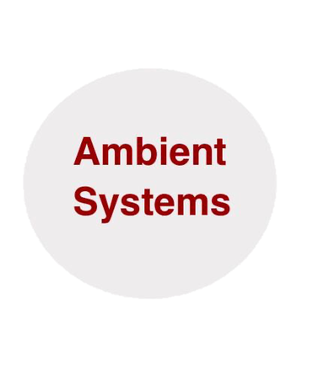
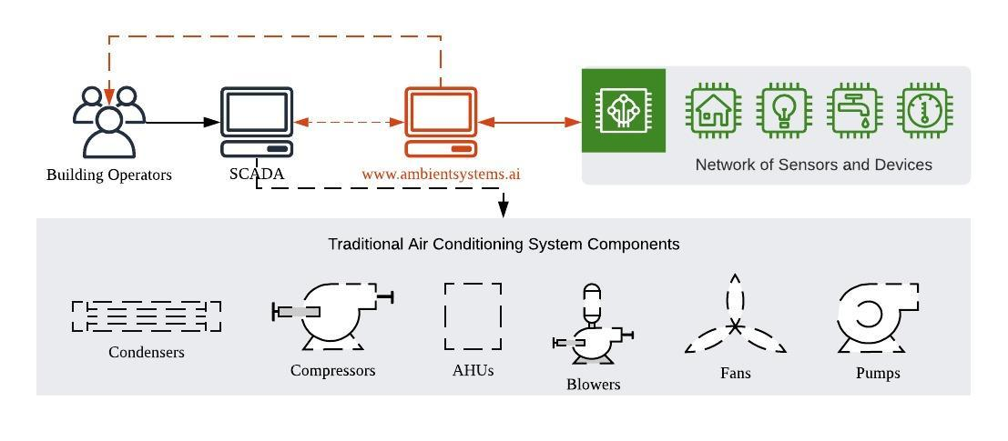
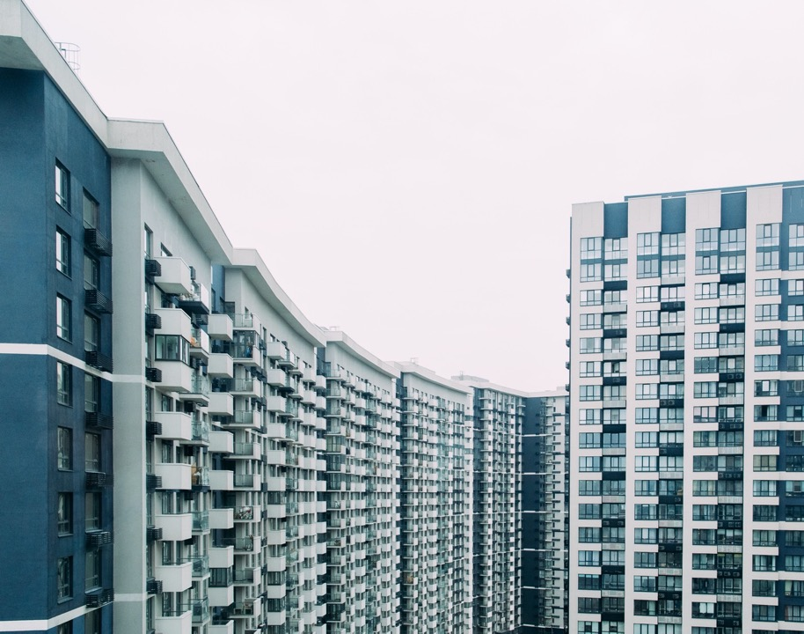

What makes Ambient different?
- Technology tailored for unique building operations and occupant needs
- Seamlessly connects to the building’s existing SCADA system and provides notifications directly to the operators
- Adds an additional layer of intelligence using AI-enabled optimization models
- Managed on the cloud and available across your devices
- Enabled by a network of interconnected sensors and devices (Internet-of-Things)
- Leverages NUS intellectual property to minimize maintenance and energy costs
* Focus is on building’s systems related to managing indoor air quality, namely mechanical and electrical systems as well as relevant sensors and controls
** Based on unique building needs. Common input parameters: temperature, relative humidity, CO2, contaminants, occupancy, and user feedback.
*** Platform outputs are available online, delivered by email/message notifications, or connected to your building’s SCADA system.
System Overview and Implementation Process

